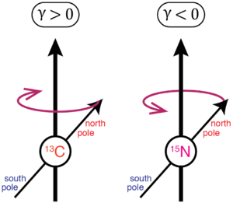The difference in precessional direction is due to the difference in gyromagnetic ratio between certain particles. If the gyromagnetic ratio is positive, as in the example from the textbook, precession is clockwise. If it is negative, as it presumably is in the video, precession is counterclockwise. There’s a helpful image in the Wikipedia page for gyromagnetic ratio which demonstrates this nicely (at left). For NMR (which is what I do in my lab work outside of this class), this is very important. Separate spectra have to be performed for different atoms of interest, but when doing 15N NMR vs 13C NMR, the precessional difference can affect shim settings and cause trouble.

For MRI though, the most commonly used nucleus for imaging is hydrogen, specifically 1H, the standard isotope of hydrogen. 1H, like 13C in the image at left, has a clockwise precessional direction, making the figure used in the textbook the “correct” one for use in MRI discussion.

Why is hydrogen used as the nucleus for MRI? Three main reasons. First, hydrogen is present in nearly every biological molecule, meaning that the entire body can be resolved, especially areas with high hydrogen density such as fatty tissues. Second, hydrogen has a high natural abundance. In order to image nitrogen or carbon, the 13C or 15N isotope is required. In a lab NMR setting, this is usually accomplished by labeling, but in MRI, the natural abundance of 13C in the body is only about 1%. This means that the signal coming from a 13C MRI will be much weaker. Finally, there is a principle known as relative sensitivity, which is related to the cube of the gyromagnetic ratio. 1H has a large gyromagnetic ratio, and its relative sensitivity is defined as 1.0. In contrast, 31P, which is also the natural isotope in the body (so nearly 100% natural abundance), has a gyromagnetic ratio of less than half that of hydrogen, giving it a relative sensitivity of 0.066.